Route Visualiser
Vladas Maldzius (2262803)
Muhammad Fahd Asif (2262555)
Ivan Delev (2262800)
Quentin Deligny (2262655)

Team Russian Blue

ABSTRACT
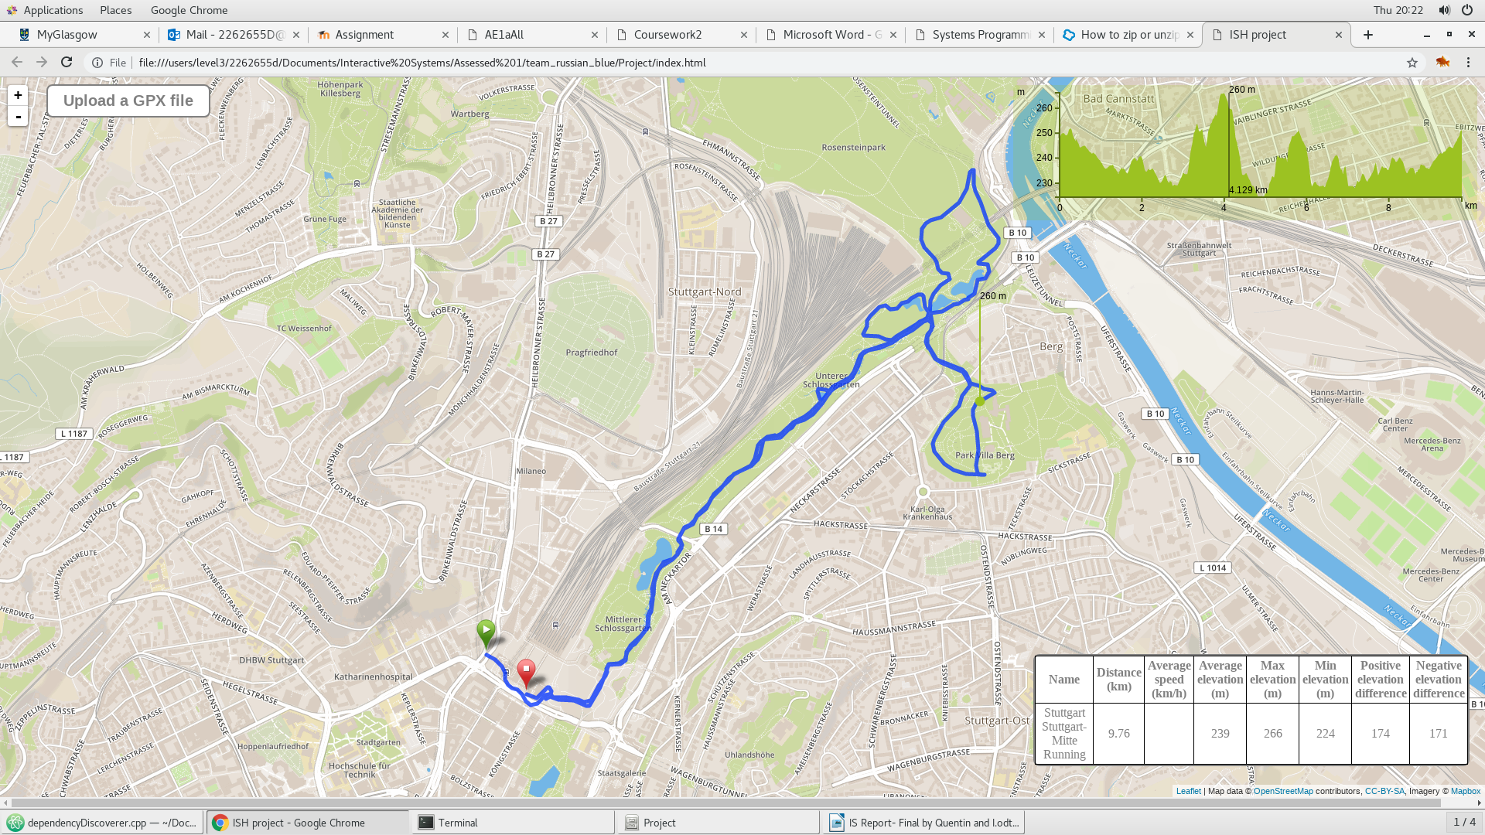
The aim of this project was to create a web-based application to view various GPX files, alongside with different selected features.
The first and most basic feature is the display of the GPX file on the map using a blue line to connect different point coordinates. Our second functionality is a graph representing the elevation of the route at any given point. We believed this to be an important requirement for runners and cyclists to enable them to make informed decisions on which route to take. Our third and final feature is a table located in the bottom-right corner of our web application displaying data on different characteristics of a given route.
The survey conducted among various users gathered mostly positive feedback; it emphasised the effectiveness of the prototype’s intuitive controls and proved the merits of a minimalist design. The qualitative feedback indicated that users had a positive experience of our product, and were likely to use it themselves or recommend it to a friend.

INTRODUCTION
As part of the group assessment for Interactive Systems, our task was to create an application implementing an interface to view GPX files. To do so, we decided to use the Leaflet API to add a list of coordinates to a map since we were already familiar with using Leaflet and we believed it would suit our purpose.
Concerning the design of our web application, our initial approach was to use a more traditional website model: the map would be displayed in the centre of the page, the legend would be positioned alongside the map, and finally the page would contain various buttons to load different files, display features, view potential scenarios… However, our final design is much more simplistic and practical: we did not implement any colour scheme or other standard website design elements. Instead, we decided to enlarge the central map to make it occupy the entire page and have buttons and other information directly displayed on the map. We therefore removed buttons which were not needed to avoid clutter of the map. We made this design decision as it was the best way to optimise the space on our web application, and to make sure we used all of it. This was particularly important to us given the nature of the project; having to display a map with eventual markers to be added on, readability was essential.
Regarding the layout of our application, we decided to display all the required features on the same page, as we did not see a need for having separate pages (although this would be considered only if the application was to be further developed by implementing a user system for example).
These two decisions that we made as part of our approach to the project enabled us to implement a concise and simple application, which is very easy to get used to. The minimalist visuals have been optimised for practical purposes, and as a result user feedback indicated high ease-of-use.
Finally, the feedback gathered by our survey gave us some clear indications on what the strengths and weaknesses of our product were. The system is very intuitive and easy to navigate (only a single load button) for users, at the cost of extra features such as a voice display or extra features (weather display, speed). The simple design contributes to making it appealing to users, and we have made the map as practical as possible (by enlarging it) at the detriment of adding other visuals around it. Thought was given to removing the possibility to add more than 1 GPX file at a time (to reduce screen clutter), but the survey made us realise how valuable the comparison feature was to runners and cyclists. Therefore we decided to keep it in our final prototype.

Project Concept
Our concept for this project has evolved over time, and the final prototype we offer is very different from what we had in mind at the first milestone of the group assessment (submitting the project review). We initially decided to target all types of users as our audience, but this implied too many constraints for a prototype. For example, our concept included a display of different universities (or other chose locations such as bars, clubs…) on a map to enable users to view different possible routes to the location of their choice. This was too ambitious, and we realised we did not have the technical tools (such as a database of all locations their associated GPX files) and time at our disposal to make this work. This is why we decided to reduce our target audience to runners and cyclist mostly, and focused on designing relevant features; users would use our application to view and compare different tracks based on various functionalities.
We have also revisited our interface to simplify it, given that our map would fill up the entire page. Instead of having buttons to toggle different GPX files (for running, cycling, walking or other activities), we incorporated only one upload button which would give the user the choice to select the file he needs, rather than working with pre-sets which may not be relevant to a specific user.
Our main feature is being able to view the GPX file on a map, anywhere in the world, provided the format of the input file contains no errors. The file is shown by a blue line tracing the route on the map iterating over the coordinated from the input file and connecting each point to the next. Another of our visualisation techniques is the display of a graph indicating the elevation of any given point on the route as a function of its distance to the origin. The lower boundary of the y-axis is the lowest elevation observed on the current route (instead of 0) to make it easier for a runner or a cyclist to observe the changes in elevation. The graphical representation of the elevation was designed to enable the user to better visualise the changes (which would have been harder if we only had displayed a number). This choice was also made to add precision to the data, as we could represent the elevation at any given point of the route (rather than only showing the overall altitude change). Finally, our third output technique consists of a table displaying different attributes for the selected route such as the distance covered by the track, the average speed of the runner, the minimum, average and maximum elevation of the route as well as the positive and negative difference in elevation.
Another feature that we have chosen to implement following the conducted survey is the ability to compare different tracks. We believed this would make the applications more appealing to users looking to compare their performance. Thus, it is possible to load and display up to 3 GPX files at the same time in order to compare them; each of these files will have an attributed graph (showing elevation variation) and table.

Implementation
Given our choice to implement all the features of our web application on the same page, most of our system is implemented by a single file (index.html) and a GPX parser (in JavaScript).
The main function in the GPX parser takes a string input (the chose file) assumed to be in the standard GPX format. We query file header information and iterate over the data: since we know what to expect from the file, we can extract the relevant information for each point in the route (such as latitude, longitude, time, element…) which we will use to compute some of the displayed features. We use an array structure to store all the track points by order of appearance. Arrays in JavaScript work well because we can append and remove values from them easily. Since they are also ordered, we can easily access any point in the route (O(1)) time complexity) through its index (this could be useful if we decided to add milestones or change the colour of the route based on some feature). From then, we defined a few functions to compute different features we were interested in such as overall distance, time, distance between adjacent points or altitude.
The second part of the technical implementation of our web application involved displaying the parsed data. This is accomplished in the index file (along with the associated CSS file). The file comprises error handling for the loading function, in the case where a user would load an empty or unconventional GPX file. It adds a value to each row and column of the table using the output of the parser file corresponding to various route characteristics. We have also added helper functions to iterate over each node and visualise onto our map: converting from latitude or longitude, rescaling on the map with the correct coordinates or retrieving boundaries. We generate and position the graph highlighting the changes in elevation over the course dynamically to make sure future instances do not overlap when comparing routes. Finally, this file also implements start and finish icons for more clarity.

Peer Assessment
We have received peer assessment from one other team. It described out initial concept which is no longer relevant to the current prototype. The review underlined that our concept was very versatile and catered to different types of users. This would not apply to our current project which has been narrowed down to more specific users. The review of the user personas was positive, and no flaw was pointed out in the scenarios. Although a typical persona for this application may have changed along with the evolution of our concept, some aspects still apply (project is very user friendly, and would be accessible to all age groups provided they are familiar with internet technologies).
The peer review regarding the wireframes was insightful, and is one of the reasons that pushed us to adapt our concept. The review indicated that the purpose of some buttons was not clear: toggling between different scenarios (to load pre-sets) was not necessarily helpful to any specific user, why have altitude, speed and temperature buttons (they did not see a need to hide these features using buttons), lack of focus on the general mapping of a route (the map was possibly too small on our original wireframe).
Following this review, we completely changed the design of our website. We began by removing some of the unnecessary buttons (and therefore directly displaying the data in a corner of the page), gave the user more freedom (to choose his own GPX file) and provided a cleaner interface. We also reshaped the map to make it fit the entire page, as this was quite important for an activity-oriented site.

Evaluation
To gather feedback for our web application, we created an online questionnaire via Google forms. The form is structured in such a way that the users are being requested to answer a limited set of questions; hence, ensuring that the users do not lose their interest and the feedback is of a good quality. The questionnaire contains a mix of questions that allow the user to provide us with both quantitative and qualitative feedback, allowing us to gauge the prototype’s impact during user tests, or what sort of changes would be needed within the prototype to improve the overall user experience.
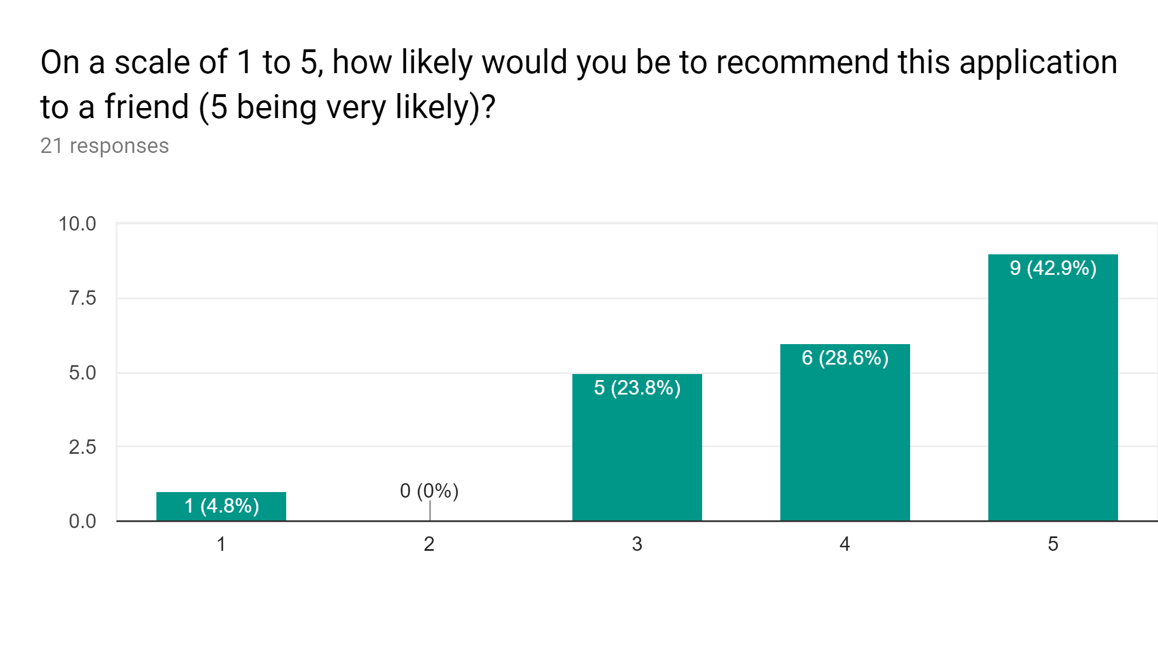
The graph defined above shows that the majority of the users found the application very appealing, easy to use and would not mind recommending it to their friends. 42.9% of users rated the application as high as 5 stars and 28.6% of users rated it as 4 stars when they were asked about how likely they were to recommend the application to their friends; thus, these figures tell us that our application is producing the desired result and matching the majority of user expectations. The graph also states that 23.8% users rated the application as 3 stars and were satisfied with the application and its functionality. Remaining 4.8% of users (1 person in our case) were not satisfied with our application’s performance and wanted some sort of changes in it, before they could refer it further to their friends. Overall, the product made a good first impression.

Results
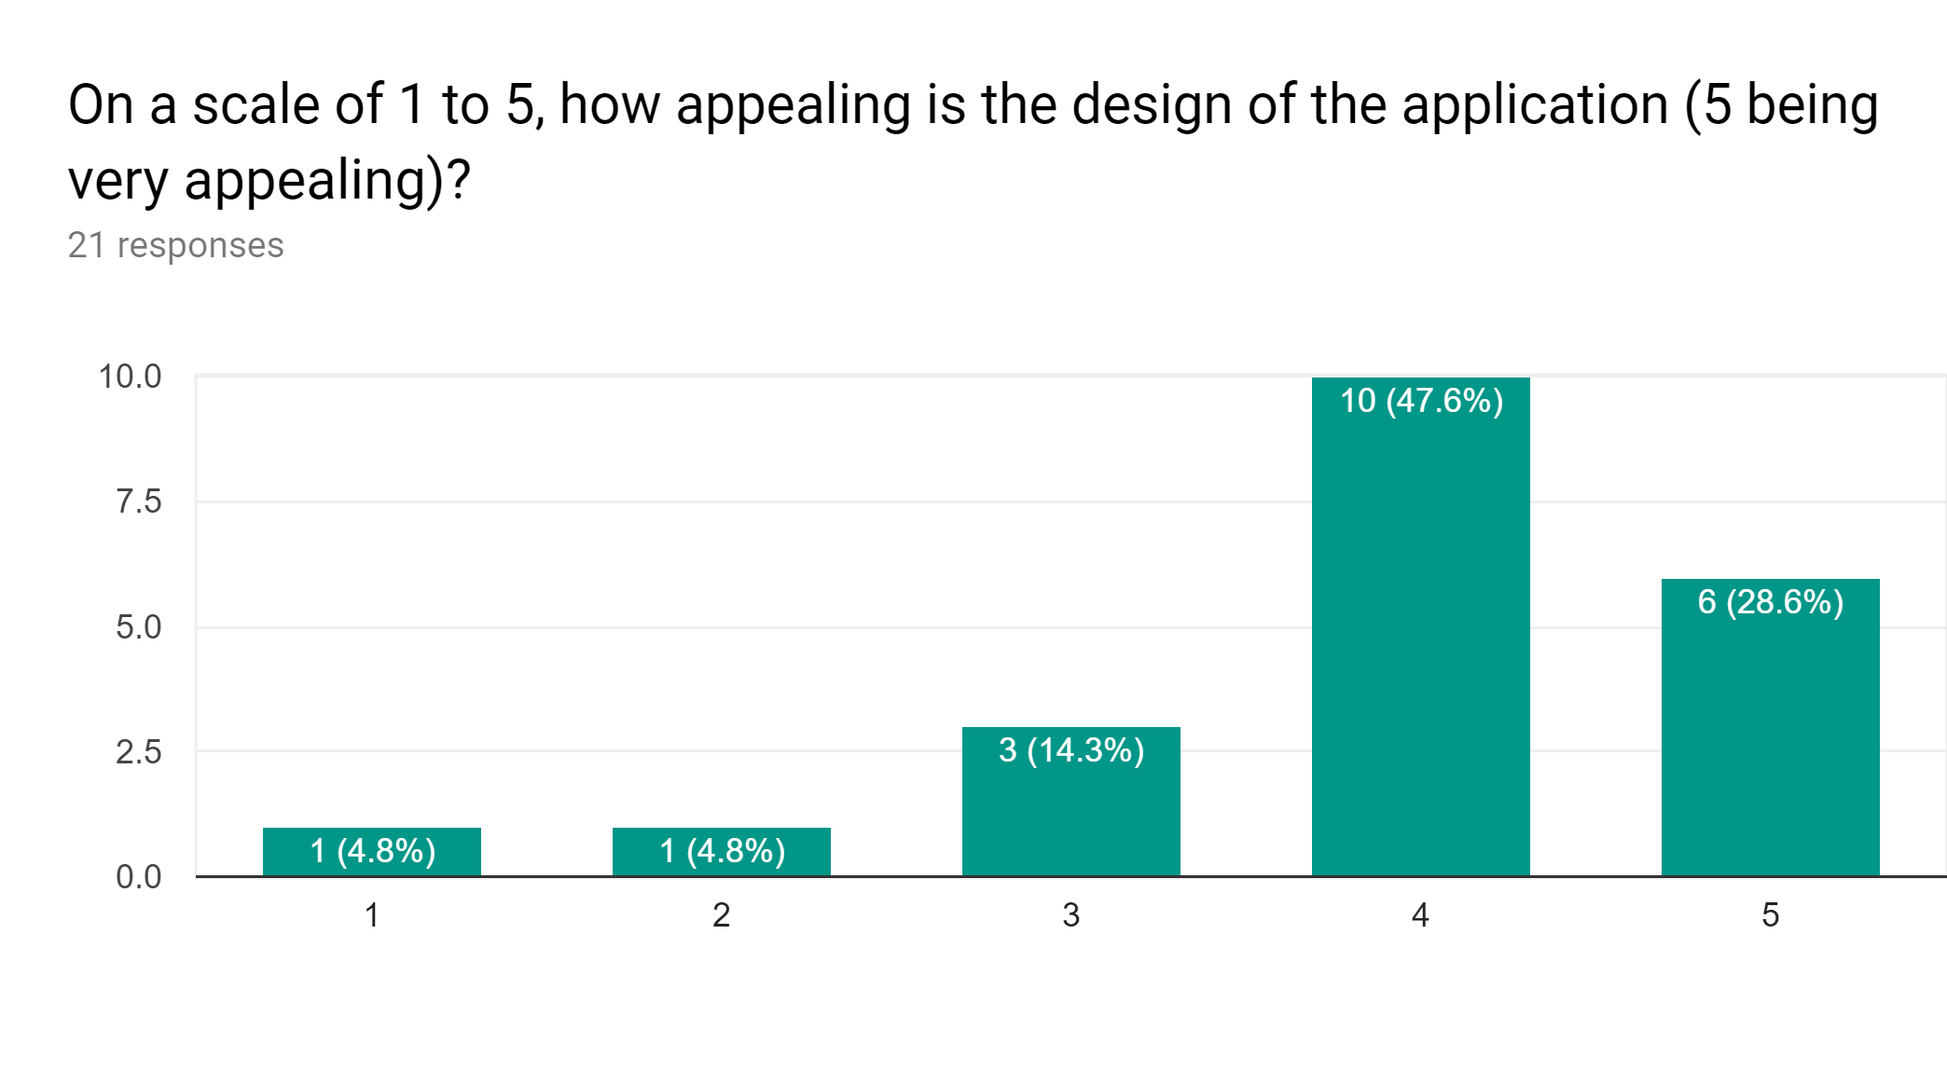This graph shows that majority of the users found the design of the application really interactive and user friendly. Indeed, 47.6% of users rated the design as 4 stars and 28.6% of users rated its design as 5 stars; therefore, this shows that the application design was very appealing to the users; and they did not encounter any sort of difficulties while using it. They had a clear and concise understanding of how the application can be used, along with its purpose. 14.3% of users were satisfied with the applications as they rated it as 3 stars. Remaining 9.6% of users struggled with the application and its user interface. To improve that, we should include some sort of a manual or a set of instructions which can help them in developing a thorough understanding of the application. Aside from providing further documentation, the current design is very minimalist and cannot be simplified further to satisfy these users (all interactions are represented by a single ‘load GPX files’ button). All in all, the design and concept of our application is clear to most users, along with its purpose.
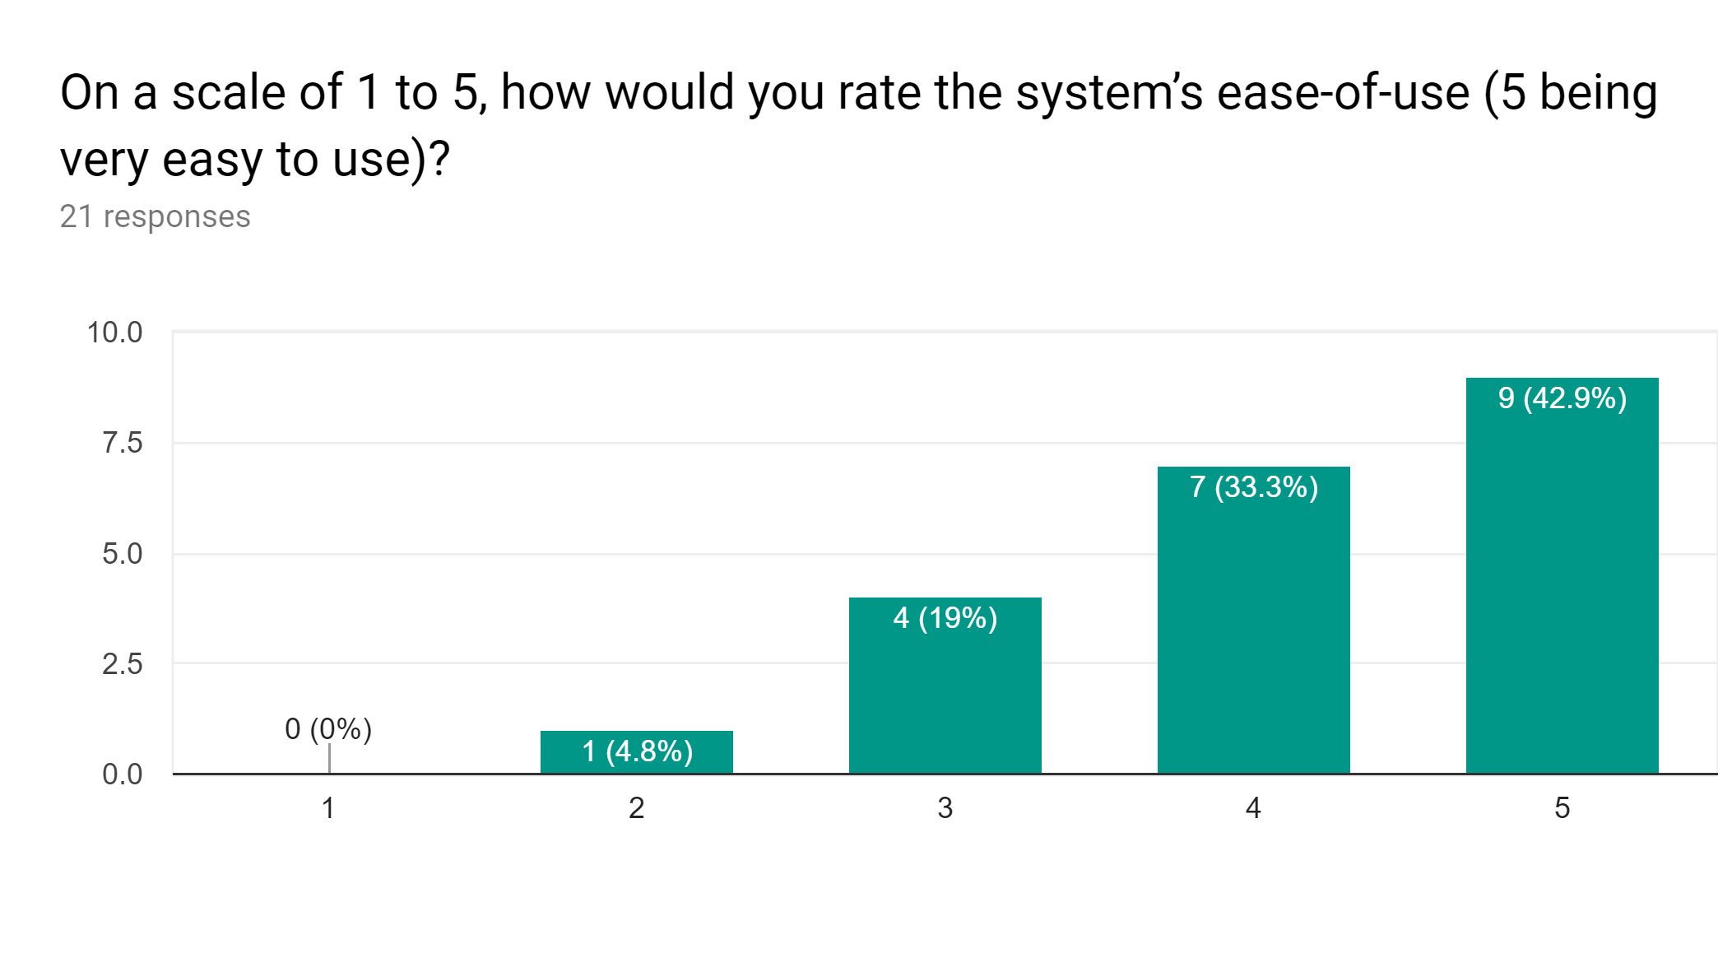
This graph tells us that most users did not have any sort of difficulty in using the application. 42.9% of users rated the ease of use of the application as 5 stars and 33.3% of users rated it as 4 stars. Thus, this demonstrates that most users successfully understood the concept of the application without any difficulties, along with its features. Furthermore, 19% of users were neutral in this situation and were satisfied with the ease of use of the application. Only one user was struggling to use the application and did not find it easy to navigate as shown by his 2 stars rating. Overall, the application was considered very easy to use as a majority of the 21 responses indicate that the concept was concise and easily understood. This is a key point for an application that is willing to spread to a great amount of users, as people are generally more likely use an application if its purpose is clear to them.

DIscussion 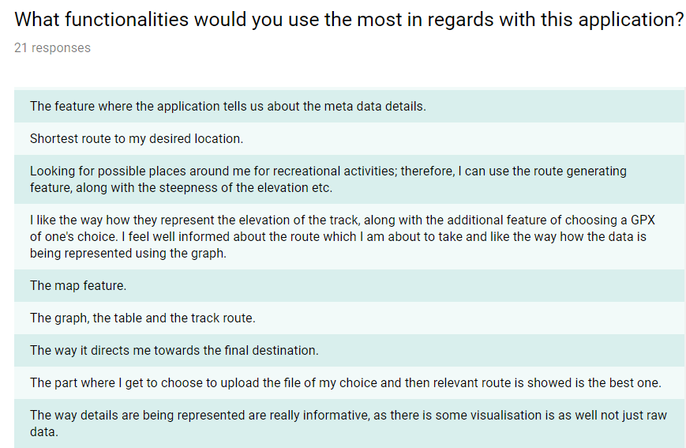

This image contains qualitative data as shown by the responses of some of our users when they were questioned about the common features they had liked or enjoyed about our application. If we were to take the exact words from one of our responses,” I like the way how they represent the elevation of the track……. being represented using the graph.”, it highlights the main features of our application: elevation graph, a well-informed route, a chance for a user to pick a GPX file of their own choice, the statistics table and a visually pleasing representation of the data. This shows that the concept and message of our application was conveyed to its users via its features. Furthermore, people were happy to use this application in their business as usual (BAU) routine; thus, ensuring that our application is fulfilling its purpose.

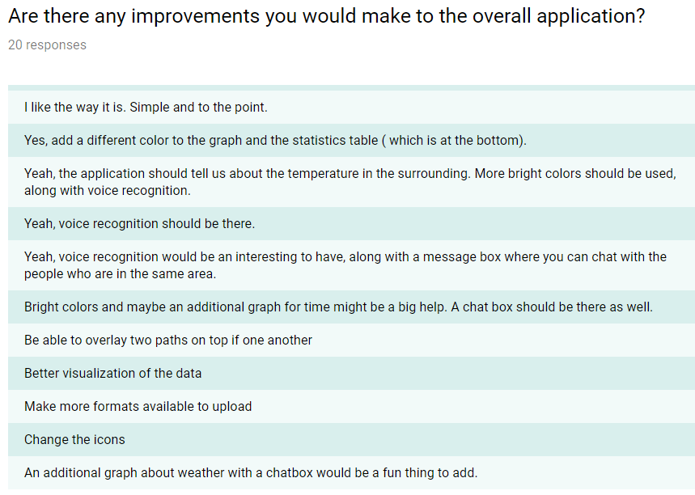

The users were also requested to suggest to us some improvements and new features they would like to see in our application. The above image shows some of their desired features and potential improvements. A vast amount of responses are suggesting that most users want a customised application with a set of new features, along with a well-defined structure, and if these changes were to be brought into our application, users would engage more with it. The suggestions include the following features:
- Voice display
- Chatbox
- Weather update gauge
- Bright colours
- Improved visualisation of the data
The above-mentioned list of features has some really good ideas that can be implemented into our application. We can use a voice displaying feature to present the application’s various functionalities to users with hearing impairment, so that our application becomes accessible to a wider audience. This seems like a feasible feature which would just need an implementation of an API that uses voice display (from an input pre-recorded audio file) to understand what action the user wants to take (comparison, load file, representation). We can also use an API for the Chatbox where the users will have the opportunity of talking to other users who are near their current location; this could help the users to meet new people and compare their performances over various tracks. A weather gauge could be added to keep the user updated about the weather conditions for the specific route. This would prove very useful to our target audience consisting mainly of runners and cyclists. Additionally, improving the colour contrast, along with the data visualisation should be easier to implement (compared to the implementation of the Chatbox, or a Weather gauge etc.) as we have already worked on it; therefore it would only require minor changes.

Conclusion
After reviewing both the quantitative and qualitative feedback in the previous sections, the prototype which we have given out to users has been a success. The feedback of the survey was very positive, and we have gathered different suggestions which would benefit user experience. This demonstrates that our application made an overall good impression among the users and strengthened the fact that users did not struggle to use the application and its features. The prototype was clear and concise, and properly fulfilled its purpose. The image below shows the responses of the users to the question where they were requested to tell whether they would be interested in using the application in the future.
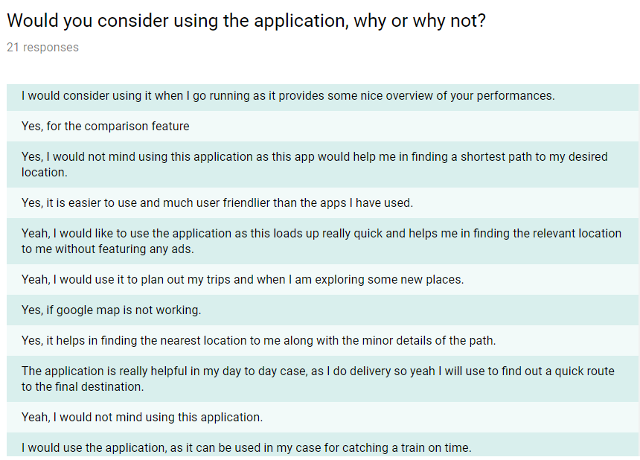The responses clearly tell us that most users would be interested in further using our prototype for their daily routine. This survey leads us to think that our prototype would be successful if some of the suggestions were implemented.

REFERENCEs

https://docs.google.com/forms/d/1iFHADgVefoS4MgsQGPShqQyFQF441NPoOAogWTtiesw/edit?usp=sharing
- https://leafletjs.com/
- https://www.awwwards.com/20-inspirational-examples-of-interactive-maps-and-street-view-experiences-in-web-design.html

